# Manual testing-

**Syllabus-**

**Manual Part 1 – (Tester 1) (web application)**

1. **Basic software testing** – QA/ QC, Peoples, Company, Testing, project, etc
2. **Different types of Process** – SDLC, Waterfall module, V-module, **Agile process**, etc
3. **Different types testing –** Sanity Testing, Smoke Testing, BBT/ System & functional testing, Re-testing, regression testing, UAT, Production Testing, etc

**Manual Part 2 – Real tester work**

1. Test cases design, Test cases review, Test cases execution, Defect/Bug raise, Demo/ review of functionality, Different type of report, etc

**Database testing-**

1. **Database testing** – SQL languages, SQL server tool, etc

**API testing- (Tester 2)**

1. **API testing** – API testing – Postman tool used for API testing.

**API Testing** – manual testing –

**API Testing** – Automation testing / Rest-assured – **New**\*\*

**Project management tool/ Defect tracing tool –**

1. Project – track tool – JIRA, Azure DeVos, TFS, etc – TCD, defect/ bug lock

**Automation Testing- (web-based application) (Tester 3)**

1. Java languages – Basic to advance tester points.
2. Selenium tool – web basic application
3. Framework –

**2 project –**

1. Different domain – CRM domain, etc
2. Different domain – Fintech domain/ Insurance domain, etc

# Manual testing-

**Project -**

Client, USA (Web based Application – Danske bank) 🡪 Project implemented / requirement

India (Infosys, Pune) – Serviced based company – TCS, Infosys, etc

India (Amdoc, PTC, Pune) – Produced based company – Billing Produced

**Development Testing**

(Frond end, Backend end, Database) (Manual testing, Automation Testing)

**Serviced based company -**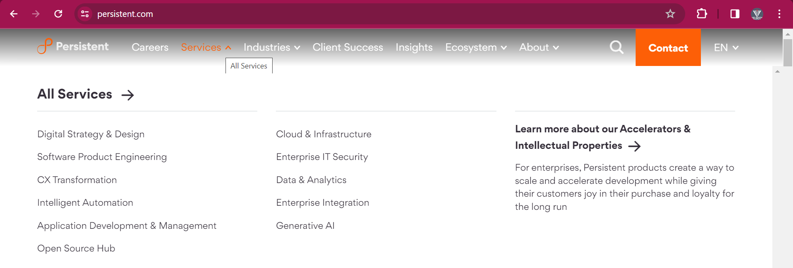

**Produced based company-**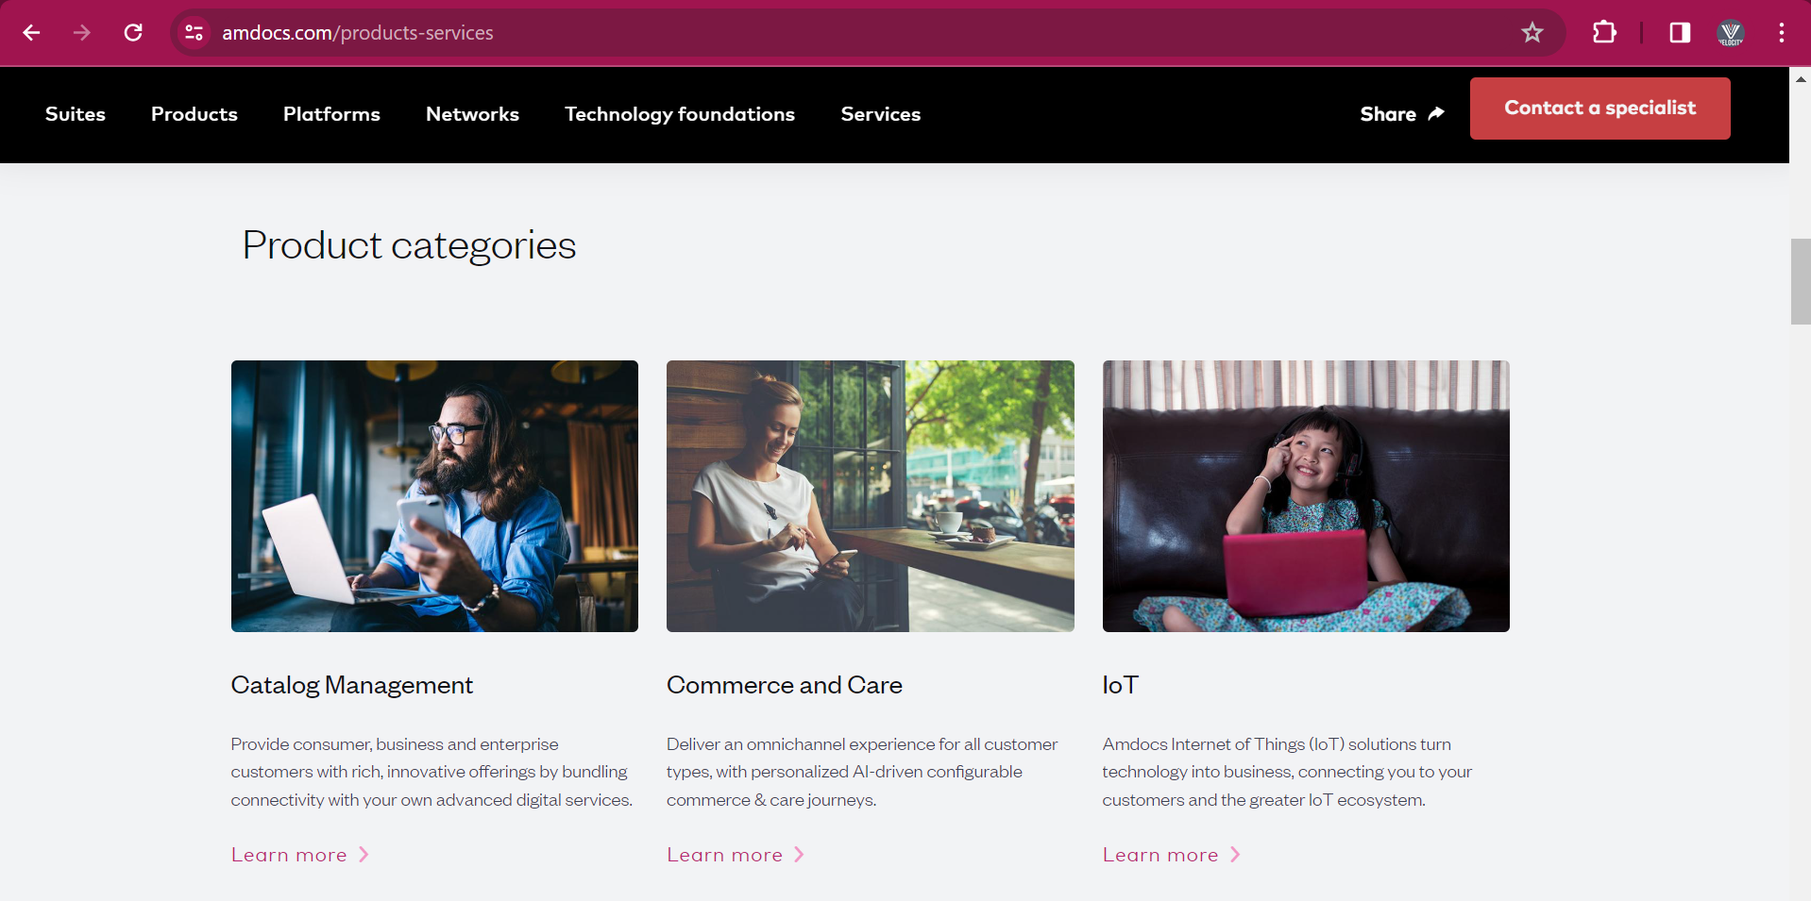

# Project work-

1. **Project development** - Newfunctionality/ New Module/ New feature addition in application.

**Ex**. Phone pay – Share market by phone pay.

**Ex**. Phone pay – Repay card linking phone pay.

1. **Project support** – Existing application issue/ bug, End user quires, Ticket, Change request, Enhancement, etc

**Ex**. Recharge, Money transfer mobile number – raised, Ticket, Call customer care – ID, etc

* Ex. Desake bank – project development & project support – Infosys company
* Ex. Softbank bank – project development - TCS company & project support – Infosys company
* Ex. HSBC bank (client) – project development – TCS, Infosys, Zensar, Cyient, Capgemini vendor company & project support – Infosys company

# Project Team size-

**Project development -**

1. **Client** – Web based application need to development/ existing web application digital transformation.
2. **Product Specialist / Business Analyst/ Consultant (BA) (1)** – Requirement collection from client. These requirements will send to project team. Product Specialist / Business Analyst/ Consultant will work as **mediator between client and project team**.

**Project Team (16 peoples) -** Newfunctionality/ New Module/ New feature addition.

1. **Delivery manager (DM) (1)** – To care of deployment/ deliveryof development functionality/ module.
2. **Project manager (PM) (1) –** project related work/ task assign and daily basis work progress ask.
3. **Designer / Solution arch. / Development Lead (1)–** Project related work for Frond end, Backend end & Database need to designer/ solution.
4. **Developer (8) –** Developer will do thecoding against

*Frond end* - they will do coding against functionality/ Module/ new feature addition

*Backend/ API end* - they will do coding against functionality/ Module/ new feature addition

*Database* – they will do coding against functionality/ Module/ new feature addition.

1. **Testing Lead (1) –** testing related work – testing report generation, framework impalement, Testing related process/ documents, etc
2. **Tester (3) –** Testing/ checking these implements functionality/ Module/ new feature addition as per given requirement.

* **I have worked**, **in project team** with **team size of 16 peoples**.

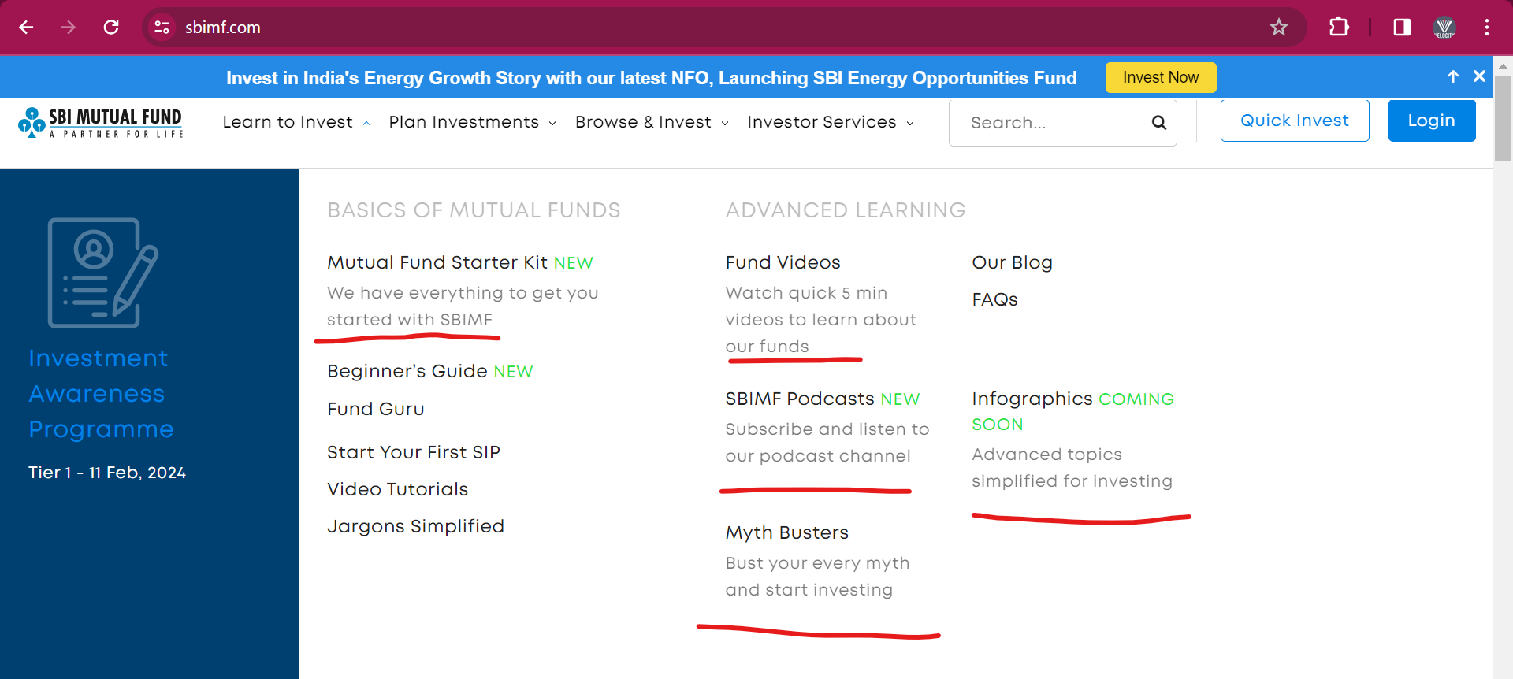

**Support Team (4 people) -** Existingapplication**/** functionality/ Module– Issue, Bug, New feature, Enhancement, User request/ quires, Ticket, etc

1. **Support/ Customer manager (1) –** Support project related Issue, feature, Enhancement, etc assign to developer and tester.
2. **Developer (2) –** Developer will do thecoding againstIssue, Bug, New feature, Enhancement.
3. **Tester (1) –** Testing these Issue, Bug, New feature, Enhancement which is development.

* Depending on project work, Project team size will be very.

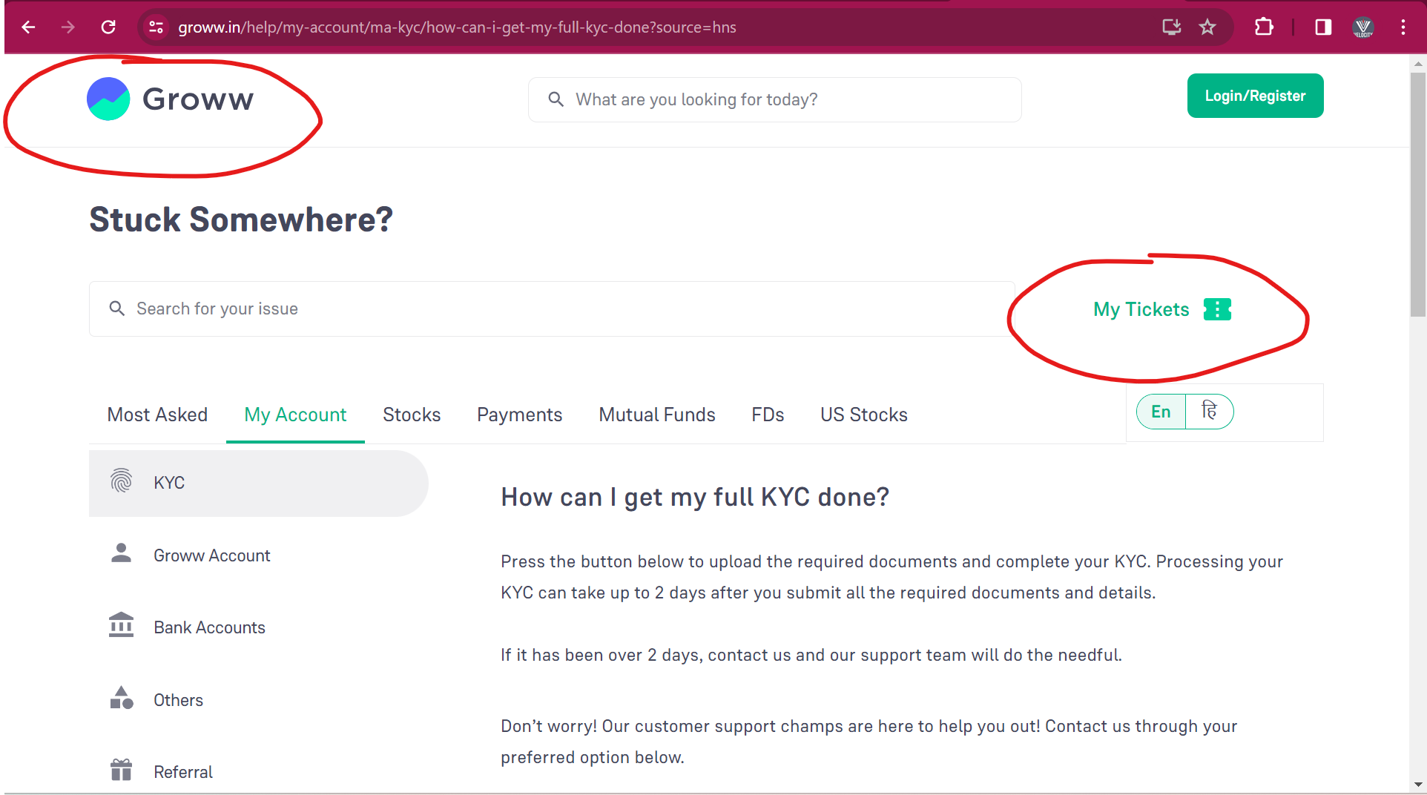

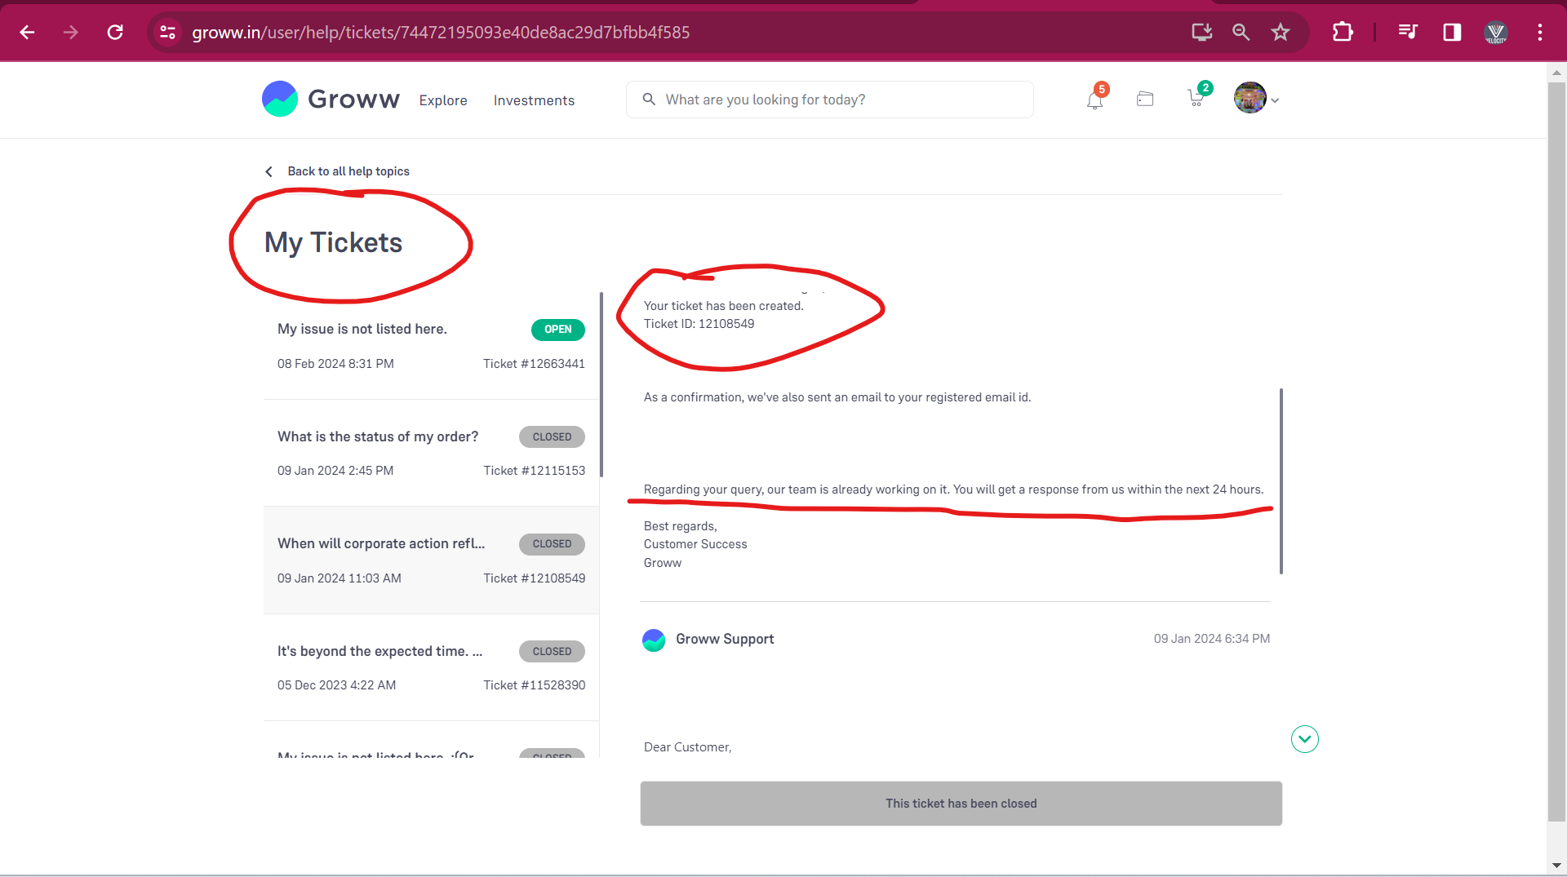

**Module-**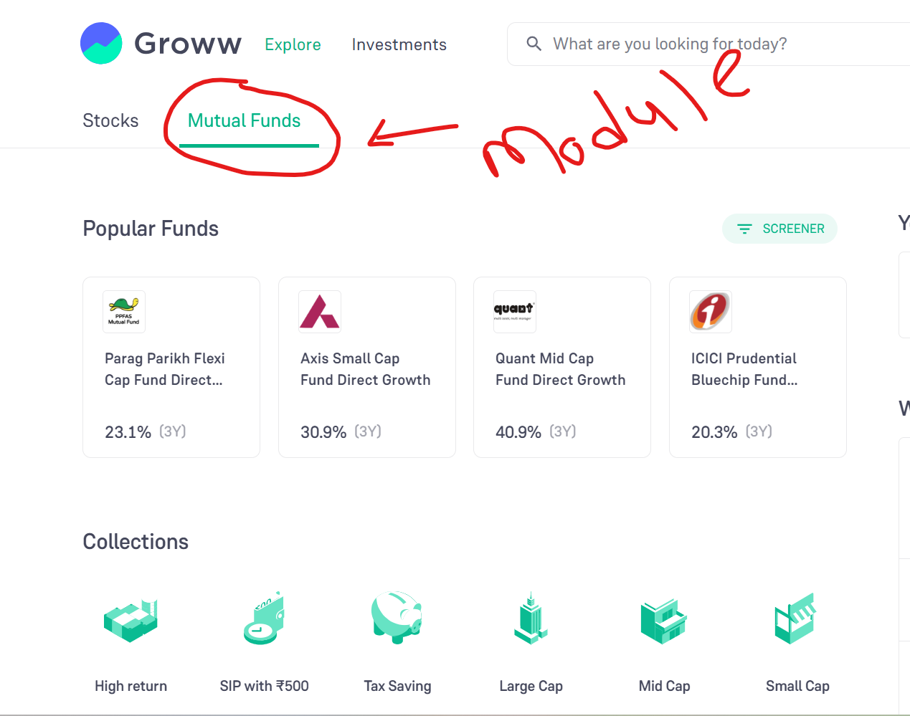

**Feature-**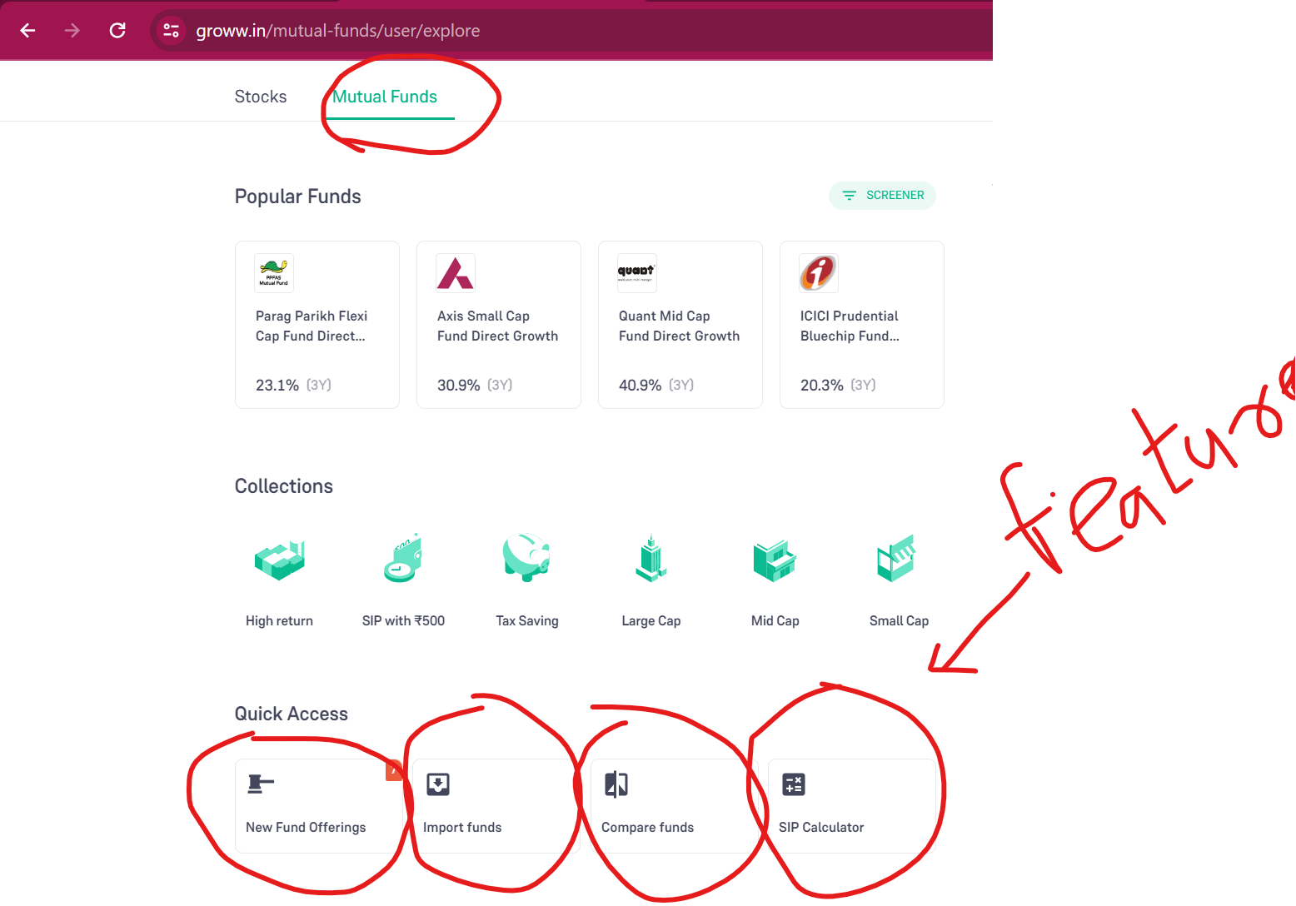

**Functionality-** 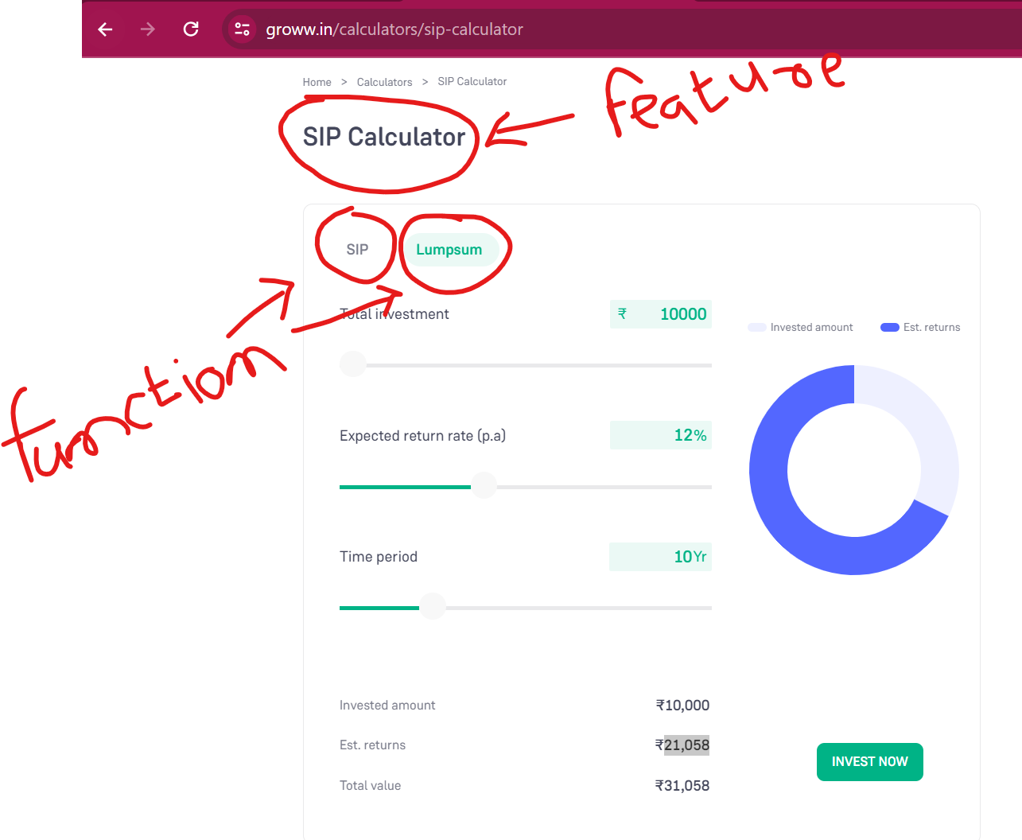

# Software –

* Software it is set of program/ collection of programs that helps to run the application.
* Types of software –

1. **System software** – OS, Driver- audio software, etc
2. **Application software** –
3. Web based application (ex. Paytm, IRCTC, https://hbl.in, vctcpune.com),
4. Mobile based application (ex. Paytm, Swiggy),
5. Desktop based (ex. PVR ticket online), etc

# Software Testing -

* To check/ verify the software application as per the requirement.

**Why software testing need-**

* To avoid bug/ issue in application
* To identify the bug/ error in application
* To gain customer confidence/ satisfy
* To increase the productivity/ quantity
* To check software adaptability/ suitability
* To avoid risk in the business.

# Different types of process follow in project-

* **Process –**
* Process will be decided by company or client will be decide.
* Process different types –

1. SDLC (software development life cycle)/ Basic process
2. Waterfall process
3. V-module process
4. **Agile Process – 90 to 95% in every project these processes follow.**

# SDLC (software development life cycle)-

* SDLC called as software development life cycle
* SDLC will contains stage/ phase –

1. **Information gathering - BRS**
2. **Requirement analysis – SRS/ FRS/ CRS**
3. **Designing**
4. **Coding**
5. **Testing**
6. **Support/ maintenance**

**Information gathering-**

* In Information gathering stage, BA will work
* BA will collect all **requirement related to client business.**
* BA will make a document related to this client business requirement **and it is called as BRS** (business requirement specification).
* BRS will contains only client business ideas.
* Client business reequipment –
* **Ex**. Client – application/ platform – customer/end user bidding – Cricket, Football, Kabadi, etc – Client business will increase when customer/end user will be bidding on cricket. – Platform charge. (ex. Dram11 – end user 10*10rs = 100rs – winner prize = 90rs and 10rs will be charged as Platform charge)
* **Ex.** Client – application/ platform – customer/end user will be providing loan – Client business will increase when customer/end use will take load and repay with intersect rate.

**Requirement analysis –**

* In **Requirement analysis stage,** BA will work.
* BA will collect all **requirement related to application/ software/ system** from client.
* BA will make a document related to this application/ software/ system requirement **and it is called as SRS** (system requirement specification/ software requirement specification).
* SRS also called **FRS** (functional requirement specification)/ **CRS** (customer requirement specification)
* SRS will contain (Phonepay project - **Recharge module - SRS)**

1. **Functional requirement** (1 module = Recharge module = 10 requirement)
2. **Functional flow diagrams**
3. **Use cases / Single specific requirement**
4. **Description –** Details about the Use cases / Single specific requirement
5. **Acceptance criteria –** Does & Don’t about the Use cases / Single specific req.
6. **Screenshot / Protype/ Wireframe**

* **Ex.** Phonepay project – **Recharge module (SRS) –**

**Flow requirement –**

**Req1- Sing up,**

**Req2- Login page -** Existing customer – Login mobile no & Email ID, error message

**Req3- Home dashboard/ page – Recharge Icon,**

**Req4- Recharge Mobile details,**

**Req5- Plane related to operator & Circle,**

**Req6- Browser plane related to circle & operator,**

**Req7- Promo code,**

**Req8- Payment debt card/ credit card,**

**Req9- Thanks message, Emails/ SMS generation.**

* BA after confirmation from client then sent to project team.
* When these SRS will be complete then BA will send these SRS document to project team.
* Project team, will read/ understand these documents.
* If there is a problem or not understand some requirement, then project team will take one call/ meeting with BA.

**Designing-**

* In designer stage, **Designer / Solution arch. / Development Lead** will work.
* Designer will prepare a protype (HLD & LLD) for these requirement/ functionality (Frond end, Backend & Database)
* **HDL** – high level design (**Ex**. Functionality – Frond end mobile no. details page – Mobile no. – API call to take detail of these mobile no.- DB will store details)
* Designer will give this work to developer.

**Coding –**

* In coding stage, **developer** will work
* Developer will do coding against these LLD (low level design) interns of Frond end, API and database.
* In LLD – Frond end, API & DB related coding performed
* Ex. **Frond end** – Mobile no enter details page – 10 digits text box, operator plane select tab, Operator select drop down, Browse tab, Amount – text box (10rs to 9999rs)

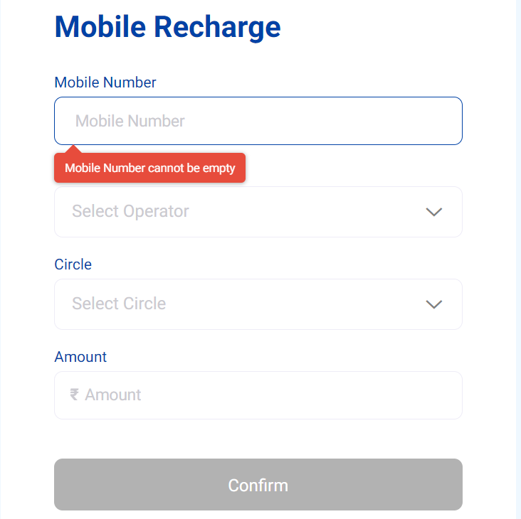

* **API coding** – GET call, POST call, etc

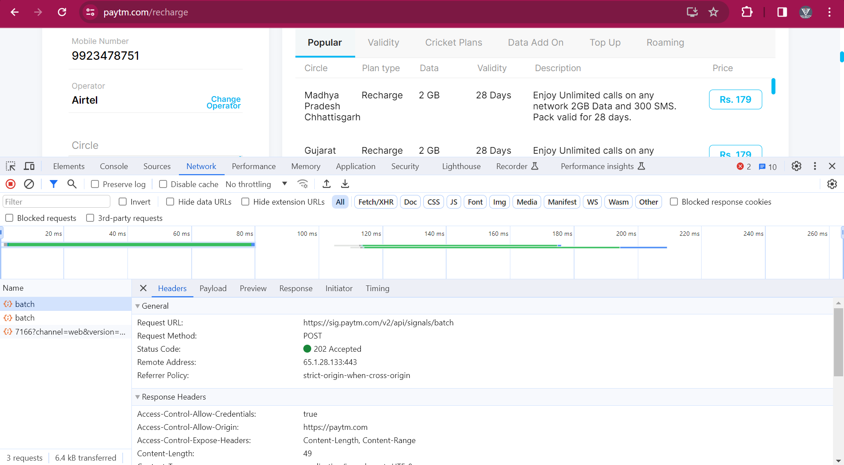

* **Database Coding** – Logical program in DB - Stored produced, functional, etc

**Testing-**

* In testing stage, tester will work
* Tester will **write test cases (TCD) & do the Test cases execution (TCE).**
* In Test cases execution, Tester will check/tetsing these implemented functionality as per requirement.
* In Test cases execution, If Tester found any issue the tester will raise the defect/ bug and inform to developer.

**Support -**

* After completion of all development & testing, these modules will send to client.
* After that these modules will provide/ handover to support team.

|  |  |  |
| --- | --- | --- |
| **Company** | **Client (USA) deployed with 1 week** | **Client (USA) deployed with 1 month** |
| Development – Bug Fix by developer | UAT – Developer | Support team developer – fix these bug |
| Testing – Bug found | UAT - tester | Support team Tester – test these bug |
| Bug | Bug | Bug |

# Waterfall Module/ process-

* Waterfall process, it is **sequential process (one after another).**
* Sequential process means after completion development /coding of all completed module then only testing will start.
* In Waterfall process, **delivery / deployment this time is not fixed/ more than 3 months.**

**Information**

**Gathering** - BRS

**Analysis –** SRS1**–** 1 module = Recharge, SRS2 – 2 modules = Insurance

**Designer** - HLD- SRS1, HLD – SRS2

**Coding** – Recharge- Bug fix + Insurance Dev X

**Testing** – TCD & TCE – Recharge- Bug

**Support** – Bug -

* In Testing – Tester has found issue/ bug – above 500rs recharge not working.
* All these bugs related to Recharge module, tester will note down and make a note (bug = 5 bug).
* When we got new module requirement then developer will do coding against the old bug fixed and new module coding.

**Dis- advantage –**

1. **Delivery / deployment** this time is **not fixed/ more than 3 months**.
2. In testing if we found bug/ issue/ defect then **backtracking (coding) is not possible.**

# V-module/ process -

* V stand for **Verification & Validation**
* V-module/ process, it is a **parallel process for development & testing.**
* In V-module/ process, **delivery / deployment** is **fixed with 3 months**.
* V-module also called as **Plane driver module (**3-month delivery).
* In V-module process, LCD (development) & LCT (testing) will do in **parallel.**

**LCD (Life cycle development)**  **LCT (Life cycle testing)**

Information gath. (**BRS**) Assessment of dev plane

Analysis (**SRS/FRS/CRS**) Prepare test plane

(SRS1- Recharge, SRS2-Movies) Requirements testing/ Doubt clear

Design – **HLD-** Wireframe Design phase testing

Coding – Developer -**LLD** Program Phase testing/

**WBT (white box testing)**

LLD – Frond, API, DB coding Test case design (**TCD** against SRS)

**Install Build (**Functionality) **TCE**-System & fun. Testing/**BBT** (Pune- Infosys)

User acceptance testing (**UAT**) - Client- USA

Knowledge transfer (**KT**) – 3-month delivery

Maintains **DRE** (defect removable efficiency) /

/Support **CR** (change request)/ **RFC/**

**Postmortem testing**

* V-module / process, Development& Testing will do Parelle
* In v-module, when BA will prepare the BRS & SRS documents then in testing stage, developer & tester will prepare a development & testing plane.
* After completion of SRS documents, then BA will send this document to project team. Project team will read or untestable the requirement. If we have problem related to the requirement then we will take one meeting with BA.
* When designer will get these SRS document then designer will prepare a HLD (prepare wireframe against that module). Then designer will give task / work to respective developer for coding.
* Developer will do LLD against the frond end, API & Database. When coding in progress then in testing stage, tester will write TCD in terms of SRS documents.
* After completion of coding then developer will do testing (WBT- white box testing). After completion development & testing, developer will send this build (module/functionality under testing) to testing.
* When tester will get this build then tester will do test cases execution. (TCE), If in TCE we found issue/ bug then we will inform to developer. Developer will fix this issue (parallel work for development & testing).
* After completion of all TCE, then tester will inform to developer. Developer will send this build into UAT environment (Client side – testing).
* After completion of all these development and testing then project team will provide KT (knowledge transfer) to support team.
* In support team will work on Ticket, Issue, CR (change request), enhancement, etc
* **DRE** (defect removable efficiency) –
* **DRE = A / (A + B)** A= No. of defect found in BBT, B = No. of defect found in UAT
* **Ex.** A = 10 defect in BBT/ Pune, B = 1 defect in UAT/ USA
* DRE = 10 / 11 = 90%
* DRE defines how much thoroughly/ deeply we have tested the application/ functionality. DRE used by PM for checking the testing activity.
* **CR** (change request)/ **RFC** (request for change) **–**
* If initially client has given some requirement after development and testing. When developer completed and delivery to client. Then client want some small changes then client sent the **CR (changes request).** CR will get from client by email.
* **Ex**. 5 Requirement in V-module – 3-month coding, testing & delivery to client – 1cr taken from client. If Client want some changes in completed/ developed then client sent CR (change requirement). For every CR company will charge to client.
* CR also called as **RFC** (request for change)
* **Postmortem testing –** Before deployment to client, in company tester will test the functionality/ build in with main functionality in the application, these testing will call as **Postmortem testing.**

**V-process dis-advance –**

* In V-module, **delivery & deployment with 3 months**, it not good from client perspective.
* In V-module, if any change comes from client side (CR), for every CR company will charge to client.

# Basic SDLC –

Information Analysis Design Coding Testing Support

Gathering (**BRS**) (**SRS**) (**HLD-** wireframe) (**Developers-** LLD) **TCD, TCE**

Review (**BA**) Review (**BA**) Review (**Design**) **WBT** (White **BBT** (Black

Box testing) box testing)

Static testing/ Verification / Dynamic testing / Validation /

Quality assurance Quality Control

* **Review –** In Review, to check **correctness & completeness of your own documents**.

|  |  |
| --- | --- |
| **WBT (White box testing)** | **BBT (Black box testing)** |
| In WBT, **developer** will work | In BBT, **Tester** will work |
| In WBT, Developer will check their logical program, loop statement, condition statement, branches statement, etc | In BBT, tester will check different coverage – Input domain coverage, Error handling, Calculation based coverage etc |
| WBT also called as **Code level testing** | BBT also called as **system & functional testing** |
| WBT two types,   1. **Unit Testing** 2. **Integration testing** | BBT two types,   1. **Functionality testing** 2. **Non- Functionality testing** |
| Developer will see the code related that functionality/ module, that why WBT called as White box | Tester can’t see the code related that functionality/ module, that why BBT called as Black box |

|  |  |
| --- | --- |
| **Static testing/ Verification** | **Dynamic testing / Validation** |
| In Verification, BA will check their own documents, Designer will check their design, Developer will check their code | In Validation, Tester will work. Tester will check functionality as per requirement documents/ SRS documents |
| Verification also called as Static testing | Validation also called as **Dynamic testing** |
| Verification also called as In-progress testing | Validation also called as End- progress testing |
| In verification, quality assurance will comes define (coding will as per design). | In validation, we will define quality of the application/ module/ functionality (quality control) |

# Agile process (90 to 95%) ** -

* Agile it is iterative process (same work will done with some time period)
* it is **continuing process for development, testing & deployment** **with 2 weeks.**
* In Agile, **Delivery / Deployment to the client with 2 weeks (Server company**)/ 3 week (product-based company).
* When **any CR comes from the client these we will accept at any point of time**. If that requirement under development or under testing or under production/ Live. After accepting these requirement **PM will discuss with client.**

1. If **CR has less impact** on current development, current testing and application which is present product/ live then these CR we will consider in **current sprint.**
2. If **CR has less high impact** on current development, current testing and application which is present product/ live then these CR (client ask these CR has less important) we will consider in **next sprint OR** if CR (client ask these CR has more important) we will consider in **current sprint.**

* Agile process also called as **Values driver process** (Client priority will consider).
* Agile contain multiple framework / sub-module/ methodologies/ sub-types

1. **XP** (extreme programming) – only coding and not testing
2. **Scrum** – **Sprint** (bunch of requirements) **wise delivery with 2 weeks.**
3. **Kanban** – used for support team (bug, ticket, end user quires, CR, Ench., etc)
4. **Lean** - used for support team (bug, ticket, end user quires, CR, Ench., etc)
5. **FDD** (future driver development)- developed the application by considering future requirements from the client.

* I have worked in **scrum agile framework/ sub-module/ methodologies.**
* Ex. 1 module = 30 requirement / Use cases =
* Current work 1 = 2 week = 5 requirement / Use cases – Dev + Testing + Delivery
* Current work 2 = 2 week = 4 requirement / Use cases - Dev + Testing + Delivery
* Current work 3 = 2 week = 6 requirement / Use cases - Dev + Testing + Delivery

CR – Less impact – current work.

CR – more impact – 1 . Client high important – current work.

2 . Client less important – next work.

## Agile architecture-

**Information Product backlog** (1 SRS – 20 US,

**Gathering** (BRS) 2 SRS – 90 US, 3 SRS = 48US) = 208 US

**Analysis Sprint backlog (2-week delivery)**

(SRS – Module 1- existing Recharge – 4 req.) Sprint 1 = 9 US – combine module US

(SRS – Module 2- Movies – 15 req.) Sprint 2 = 8 US – Dev + Test + Delivery

(SRS – Module 3- Insurance – 8 req.) Sprint 3 = 10 US – Dev + Test + Delivery

Existing module Req. = 1 req. = 4US Sprint 4 = 8 US – Dev + Test + Delivery

**Use Cases /1 requirement** 🡪 BA convert 🡪 **User Stories** (1req. = 6 US)

1. Description 1. Description

2. Acceptance criteria 2. Acceptance criteria

Designer Designer – Design against the US

Coding – LLD against the US

Testing – TCD & TCE against the US

* BA will prepare SRS documents for every new module and for existing module. BA people will convert these all-SRS documents requirement/ Use cases into User stories.
* These all-User stories will add into product backlog.
* **Product backlog** – Bunch of user stories/ small work related to your project/ application which added into project management tool (JIRA/ Azure DeVos tool)
* All user stories which is present in product backlog will be added into sprint backlog. Sprit backlog user stories will decide by client (client priority/ values driven process).
* **Sprint** **backlog –** Bunch ofuser stories which will be developed, tested & deployed with 2 weeks to client.
* In sprint backlog, all these user stories will Developed, Tested & Deployed with 2 weeks.
* Designer will design the functionality accordingly to user stories and developer will do coding against the user stories.
* Tester will write test cases accordingly to user stories and TCE accordingly user stories.

**Product Backlog-** 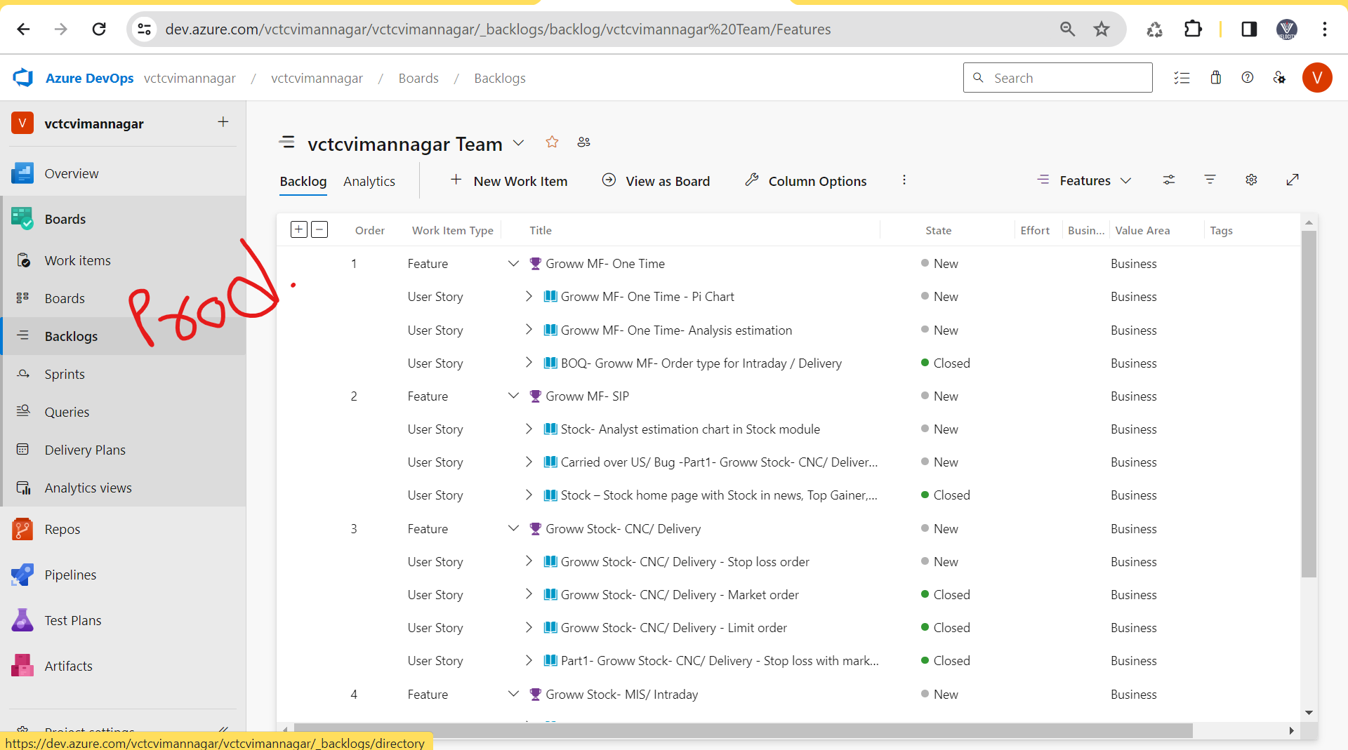

**Sprint Backlog-** 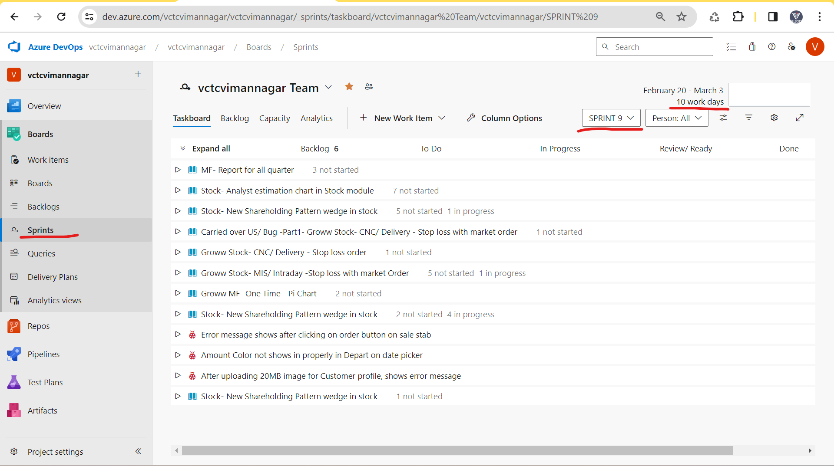

**User stroies-** 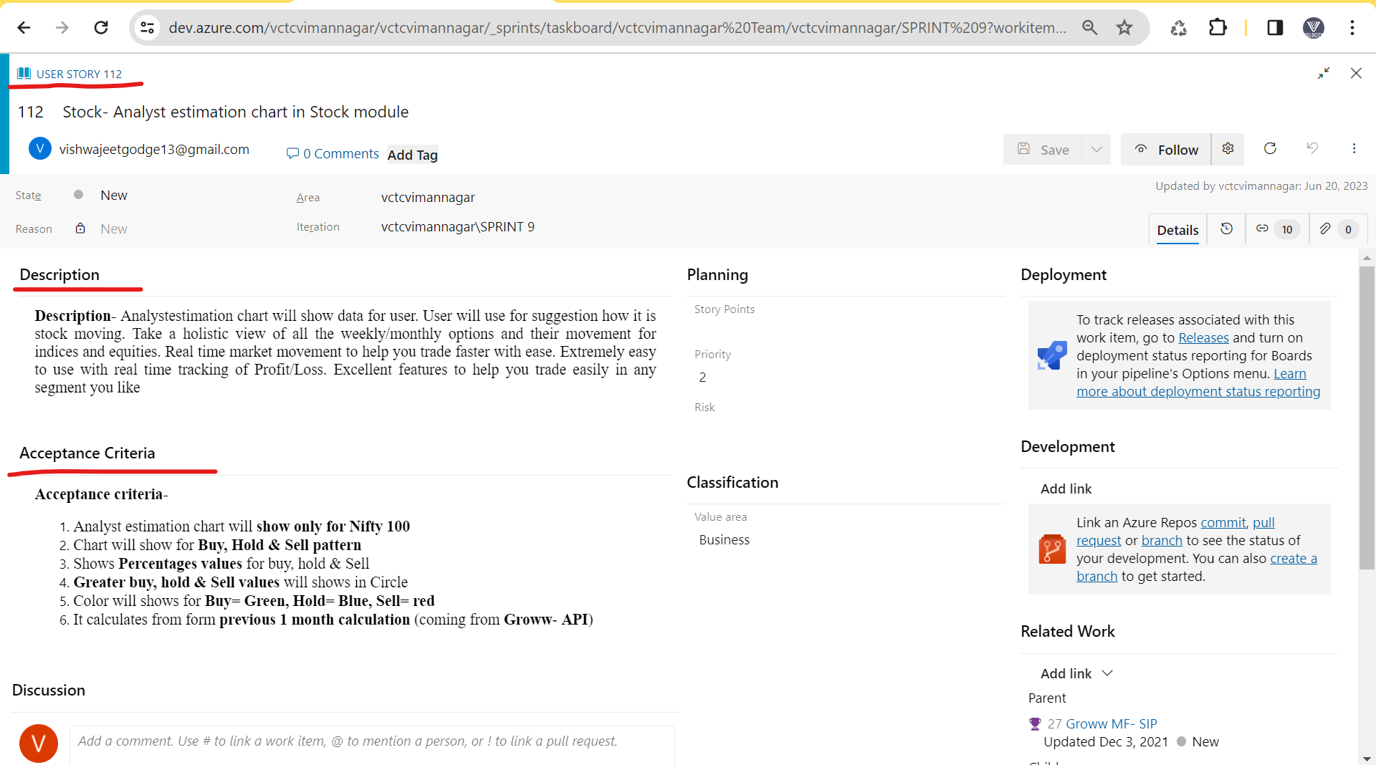

## Agile Meeting** –

* In agile we have different types meeting

1. Sprint planning meeting
2. Grooming meeting
3. Daily stand-up meeting
4. Sprint review meeting
5. Sprint retrospective meeting

|  |  |  |
| --- | --- | --- |
| **Meeting** | **Purpose** | **Involvement** |
| **Sprint planning meeting**  1 day of sprint  Time = 10 am to 11am | 1. In current sprint decide how much requirement/ work consider  Ex. Sprint 1 = 8 req. – 2-week deployment  Ex. Sprint 2 = 9 req. – (3 req. = Me)  Ex. Sprint 3 = 7 req.  2. Task/work allocation & decide the estimation/ story point against the requirement  Ex. 1 req. = 18hr Dev + 10hr Testing  Ex. 2 req. = 24hr Dev + 14hr Testing  Ex. 3 req. = 16hr Dev + 14hr Testing | **1hr – PM,** BA, Designer, Dev Team, Testing Team |
| **Grooming meeting**  Conduct at any of time | 1. Current work/ req. against if we have doubt/ clarification from BA | **1hr/30min – BA**, PM, Designer, Dev Team, Testing Team |
| **Daily Stand-Up Meeting/ Scrum meeting**  Every day at 10.00am (10am to 10.15am) | Daily work progress for each person   1. What you have done yesterday 2. What you are doing today 3. Issue / Roadblock | **15Min – PM,** BA, Designer, Dev Team, Testing Team |
| **Sprint review meeting**  Last day of sprint  (3 to 4pm) | Tester will give **Demo/ Review** of tested requirement to **Client/ UAT Tester/ BA** | **1hr – Client/ UAT Tester/ BA,** PM, Designer, Dev Team, Testing Team |
| **Sprint retrospective meeting**  Last day of sprint  (5 to 5.30pm) | Current sprint 1 – good & bad discuss related to work done in sprint 1  Current Sprint 1 – Next Sprint 2 | **30Min/ 1hr – PM,** BA, Designer, Dev Team, Testing Team |

## Scrum Agile Daily wise plane –

* Project team = 16 peoples in 8/9 developer and 3 Tester
* **Current sprint 10 = 8 US** (3 different module – 3US Recharge module, 2 US – Movies module, 3 US – Insurance module)
* **Team 1** – 3 developers (Frond, API, DB) + **1 Tester (Me) = 3US Recharge module**
* **Team 2** - 3 developer (Frond, API, DB) + 1 Tester = 2 US – Movies module
* **Team 3**- 2 developer (Frond, DB) + 1 Tester = 3 US – Insurance module
* **2-week sprint – 10 days** = 1 days * 8hr/ person = 80hr – In sprint maximum a person will work 80hr (real work in company = 50hr/ person).

**Project** = SRS = 10 req., SRS = 20 req.🡪 BA convert into User stories

**Product backlog** (US = 60US + 90US)

**Sprint backlog**

**Sprint 1 = 6US** – 2week dev + Test+ delivery (US will decide accordingly to client priority)

Sprint 2 = 7US – 2week dev + Test+ delivery

Sprint 3 = 9US – 2week dev + Test+ delivery

Sprint 4 = 8US – 2week dev + Test+ delivery

Sprint 5 = 7US – 2week dev + Test+ delivery

**1 week of Sprint- (Monday to Friday)**

**Monday (1st Day of Sprint) (office working time = 9.30am to 6.00pm)**

* **Sprint Planning meeting (Time 10 am to 11am)-**

1. In current Sprint 1 = 8 US will take that will discuss for Dev + Test + development (3US = Tester me allocated)
2. Task/work allocation & decide the estimation against the US (1 US = 18hr Dev + 10hr Testing)

* **Grooming Meeting (Time 11am to 11.30am)**

1. If we doubt against the US which is allocated (Team 1 has doubt). (If I have problem in US then we will first discuss with team lead/ tester member. If team lead also have problem, then we will conduct grooming meeting)

* **Daily work** – Team 1 = 3 developer + 1 Tester (3US – Recharge module)
* 3 Developer – 1US coding (14hr) – In-progress
* 1 Tester – 1US TCD (5hr) – Complete

**Tuesday - (office working time = 9.30am to 6.00pm)**

* **Scrum meeting/ daily stand-up meeting (Time = 10am to 10.15am)**

1. What you have done yesterday (Tester – 1US TCD – Complete)
2. What you are doing today (Tester – 2US TCD – Start)
3. Issue / Roadblock

* **Daily work** – Team 1 = 3 developer + 1 Tester
* 3 Developer – 1US coding (16hr) – In-progress
* 1 Tester – On 2US tester will do TCD (5hr) – In-progress.

**Wednesday - (office working time = 9.30am to 6.00pm)**

* **Scrum meeting/ daily stand-up meeting (Time = 10am to 10.15am)**

1. What you have done yesterday (Tester – 2US TCD – In-progress)
2. What you are doing today (Tester – 2US TCD – End & 3US TCD - Start)
3. Issue / Roadblock

* **Daily work** – Team 1 = 3 developer + 1 Tester
* 3 Developer – 1US coding (10hr) – Completed + 1US build sent for testing + 2US coding (8hr) - In-progress.
* 1 Tester – On 2US tester will do TCD (3hr) – Completed + Tester will do TCE on 1US build (3hr) - In-progress.

**Thursday - (office working time = 9.30am to 6.00pm)**

* **Scrum meeting/ daily stand-up meeting (Time = 10am to 10.15am)**

1. What you have done yesterday (Tester – 2US TCD – completed + 1US TCE - In-progress)
2. What you are doing today (Tester – 1US TCE - Continue)
3. Issue / Roadblock

* **Daily work** – Team 1 = 3 developer + 1 Tester
* 3 Developer - 2US coding (16hr) - In-progress
* 1 Tester – Tester will continue TCE on 1US build (7hr) – completed.

**Friday - (office working time = 9.30am to 6.00pm)**

* **Scrum meeting/ daily stand-up meeting (Time = 10am to 10.15am)**

1. What you have done yesterday (Tester –1US TCE - Completed)
2. What you are doing today (Tester – 3US TCD - Start)
3. Issue / Roadblock

* **Daily work** – Team 1 = 3 developer + 1 Tester
* 3 Developer - 2US coding (12hr) – In-progress
* 1 Tester – Tester will start 3US TCD (4hr) – In-progress.

**2-week (Monday to Friday)-**

**Monday - (office working time = 9.30am to 6.00pm)**

* **Scrum meeting/ daily stand-up meeting (Time = 10am to 10.15am)**

1. What you have done yesterday (Tester –3US TCD - In-progress)
2. What you are doing today (Tester – 3US TCD – try to complete)
3. Issue / Roadblock

* **Daily work** – Team 1 = 3 developer + 1 Tester
* 3 Developer - 2US coding (16hr) – complete + 2US build sent for testing.
* 1 Tester – Tester will start 3US TCD (4hr) – complete.

**Tuesday - (office working time = 9.30am to 6.00pm)**

* **Scrum meeting/ daily stand-up meeting (Time = 10am to 10.15am)**

1. What you have done yesterday (Tester –3US TCD - complete)
2. What you are doing today (Tester – 2US TCE – start)
3. Issue / Roadblock

* **Daily work** – Team 1 = 3 developer + 1 Tester
* 3 Developer - 3US coding (16hr) – In-progress + 2 Bug will fix (1hr)
* 1 Tester – Tester will start 2US TCE (6hr) – Continue / In- progress.
* 2 Bug/issue/ defect found then we will inform developer + Tester will do the testing - 2 Bug / issue/ defect (1hr).

**Wednesday - (office working time = 9.30am to 6.00pm)**

* **Scrum meeting/ daily stand-up meeting (Time = 10am to 10.15am)**

1. What you have done yesterday (Tester –2US TCE – In-Progress & 2 bug raised & tested)
2. What you are doing today (Tester – 2US TCE – Try to complete)
3. Issue / Roadblock

* **Daily work** – Team 1 = 3 developer + 1 Tester
* 3 Developer - 3US coding (14hr) – In-progress
* 1 Tester – Tester will start 2US TCE (6.30hr) – Completed.

**Thursday - (office working time = 9.30am to 6.00pm)**

* **Scrum meeting/ daily stand-up meeting (Time = 10am to 10.15am)**

1. What you have done yesterday (Tester –2US TCE – completed)
2. What you are doing today (Tester – 3US TCE – Start)
3. Issue / Roadblock (but we don’t get the build)

* **Daily work** – Team 1 = 3 developer + 1 Tester
* 3 Developer - 3US coding (6hr) – completed + 3US build sent for testing + 4 bug developer fixed & 2 bug not accepted.
* 1 Tester – Tester will start 3US TCE (5.30hr)- Continue/ In-progress + 4 bug / defect re-tested (1.30hr).
* 6 Bug/ Defect found and inform to developer.

**Friday – Last day of Sprint (office working time = 9.30am to 6.00pm)**

* **Scrum meeting/ daily stand-up meeting (Time = 10am to 10.15am)**

1. What you have done yesterday (Tester –3US TCE – In-progress & 6 defect raised)
2. What you are doing today (Tester – 3US TCE – we will complete before demo)
3. Issue / Roadblock (developer has fixed 4 defect/bug but 2 defect/bug not accepted)

* **Daily work** – Team 1 = 3 developer + 1 Tester
* 3 Developer - 3US coding (6hr) – 2 defect/bug fixed (3hr).
* 1 Tester – Tester will start 3US TCE (5.30hr)- Completed + 2 defect/bug will re-tested.
* **Sprint review meeting (Time = 4pm to 5am)**

1. Tester (Me = 3 US recharge) will give the demo/ review to Client/ UAT Tester / BA.

* **Sprint retrospective meeting (Time = 5.30pm to 6.00pm)**

1. Sprint 1 = 8US – worked – Good & Bad happed will discussion.
2. In next sprint 2 working in next week. Good – work continue, Bad work.

**Sprint 2- 7 US (Me = 3US)**

|  |  |  |  |  |  |
| --- | --- | --- | --- | --- | --- |
| **1 Week** | | | | | |
| **Days** | **Monday** | **Tuesday** | **Wednesday** | **Thursday** | **Fridays** |
| **Meeting** | Sprint planning meeting (1hr)  Sprint 2 = 7US, Task/ work allocation + Estimation | Daily Stand-up meeting (15min) | Daily Stand-up meeting (15min) | Daily Stand-up meeting (15min) | Daily Stand-up meeting (15min) |
| **3 Developer** | 1US – Coding (14hr) – In-progress | 1US – Coding (16hr) – In-progress | 1US – Build sent to Testing(1hr) + 2US – Coding (10hr) – In-progress | 2US – Coding (15hr) – In-progress + 2 Bug/ Defect fixed (2hr) | 2US – Coding (18hr) – In-progress |
| **1 Tester** | 1US – TCD (4hr) - In-progress | 1US – TCD (5hr) - Completed | 1US – TCE (6hr) – In-progress | 1US – TCE (6hr) – TCE – Completed +2 Bug / defect raised - & 2 Bug testing (1hr) | 2US – TCD – Start (4hr) – In-progress |
| **2 Week** | | | | | |
| **Days** | **Monday** | **Tuesday** | **Wednesday** | **Thursday** | **Fridays** |
| **Meeting** | Daily Stand-up meeting (15min) | Daily Stand-up meeting (15min) | Daily Stand-up meeting (15min) | Daily Stand-up meeting (15min) | Daily Stand-up meeting (15min)  Sprint Review Meeting (1hr)  Sprint retrospective meeting (30min) |
| **3 Developer** | 2US – Coding + 2 US build sent to testing (18hr) | 3US – Coding (14hr) – In-progress + 3 Bug (2US) fixed (3hr) | 2 Bug (2US) fixed (2hr) + 3US – Coding (14hr) – In-progress | 3US – Coding (14hr) – In-progress & 3SU build sent to testing. | 4 Bug fixed (3hr) |
| **1 Tester** | 2US – TCD – (6hr) – Completed | 2US – TCE (6hr) – In-progress + 5 Bug raised + 3 bug tested (1hr) | 2US – TCE (6hr) – In-progress & completed + 2 Bug tested (1hr) | 3US – TCD (4hr) – Start & completed + 3US – TCE (3hr) – Start & In-progress | 3US – TCE (1hr) – Started & 4 Bug raised & Continue TCE (5hr) – completed + 4 Bug tested (1hr) |

**Sprint 3- 6 US (Me = 2US) -**

|  |  |  |  |  |  |
| --- | --- | --- | --- | --- | --- |
| **1 Week** | | | | | |
| **Days** | **Monday** | **Tuesday** | **Wednesday** | **Thursday** | **Fridays** |
| **Meeting** | Sprint planning meeting (1hr)  Sprint 3 = 6US, Task/ work allocation + Estimation | Daily Stand-up meeting (15min) | Daily Stand-up meeting (15min) | Daily Stand-up meeting (15min) | Daily Stand-up meeting (15min) |
| **3 Developer** | 1US – Coding (14hr) – Started & In-progress | 1US – Coding (16hr) – In-progress | 1US – Coding (18hr) – In-progress | 1US – Coding (14hr) – In-progress | 1US – Coding In-progress & 1US build sent to testing (14hr) - Completed |
| **1 Tester** | 1US – TCD (5hr) – Started & In-progress | 1US – TCD (6hr) - Started & Completed | 2US – TCD (5hr) – Started & In-progress | 2US – TCD (4hr) – In-progress | 2US – TCD (2hr) – Completed |
| **2 Week** | | | | | |
| **Days** | **Monday** | **Tuesday** | **Wednesday** | **Thursday** | **Fridays** |
| **Meeting** | Daily Stand-up meeting (15min) | Daily Stand-up meeting (15min) | Daily Stand-up meeting (15min) | Daily Stand-up meeting (15min) | Daily Stand-up meeting (15min)  4 bugs clarification/ discussion  Sprint review meeting (1hr)  Sprint retrospective meeting |
| **3 Developer** | 2US – Coding (14hr) – Started & In-progress + 2 bug fixed (2hr) | 3 bugs fixed (2hr) + 2US – Coding – Started & In-progress | 2US – Coding – Started & In-progress + 2US build sent to testing | Developer code coverage checking (1hr) + 4 bug fixed (4hr) & 4 bugs doubt | 4 bugs fixed (3hr) |
| **1 Tester** | 1US – TCE (1hr)– Started + 5 bug raised + 1US – TCE – continue (6hr) - In-progress | 1US – TCE (5hr)– In-progress + 5 bugs tested (3hr) | 1US – TCE (3hr)– In-progress & completed + 2US – TCE (2hr) – Started & In -progress | 2US – TCE (2 hr) – Started + 8 bugs raised + 2US – TCE – continue (5hr) - In-progress | 4bug tested (2hr) + 2US – TCE (2 hr) – completed + 4 bugs tested (2hr) |

## Agile people –

**SDLC Agile name**

* Client 🡪 Stake holder
* Delivery Manager 🡪 Solution master
* Business annalist 🡪 Product owner
* Project Manager 🡪 Scrum master
* Designer 🡪 Designer
* Developer 🡪 Developer
* Tester 🡪 Tester

## Agile Terms –

* **Sprint refinement meeting-** In sprint refinement meeting **DM, PM, BA, Designer & Client** will be present. In sprint refinement meeting they will **decide the planning of next sprint**. Client will decide which US will take into next sprint. (Value drive process)
* **Ex.** Current Sprint 2- 7US – In **2 weeks on Wednesday/** Thursday, sprint refinement meeting will be conducted. In these meeting, decided the US which will be added into the Next sprint 3 = 8US.
* **Ex.** Current Sprint 3- 8US – In 2 weeks on Wednesday/ Thursday, sprint refinement meeting will be conducted. In these meeting, decided the US which will be added into the Next sprint 4 = 7US.
* When sprint started then PM will conduct the Sprint planning meeting – On current sprint 4 how much US we have taken = 7US. In sprint planning meeting, PM will create/ assign task/ work and ask estimation against that task/ work.
* **Epic –** Parent US which is present in the product backlog for a module. Ex. SRS = Movies ticket module = 10 Req. / Use cases. BA will convert all these use cases into Use stories. BA will prepare the epic in product backlog and add all these User stories into that epic.
* Ex. Epic (parent User stories) = Movies Ticket – 60 Use stories (child US).
* **Product backlog** – Bunch of user stories/ small work related to your project/ application which added into project management tool (JIRA/ Azure DeVos tool). All user stories which is present in product backlog will be added into sprint backlog. Sprit backlog user stories will decide by client (client priority/ values driven process).
* **Sprint** **backlog –** Bunch ofuser stories which will be developed, tested & deployed with 2 weeks to client.
* **Burn down chart –** Burn down chart define how much work will pending with respect to time. These Burn down chart will be present in Project management tool.
* **Burn Up chart –** Burn up chart define how much work will be completed with respect to time. These Burn down chart will be present in Project management tool.
* **Velocity chart –** Velocity chart defines how much work we are delivery in every sprint to client **OR** how much estimation we have given and how much actually we requirement while working.

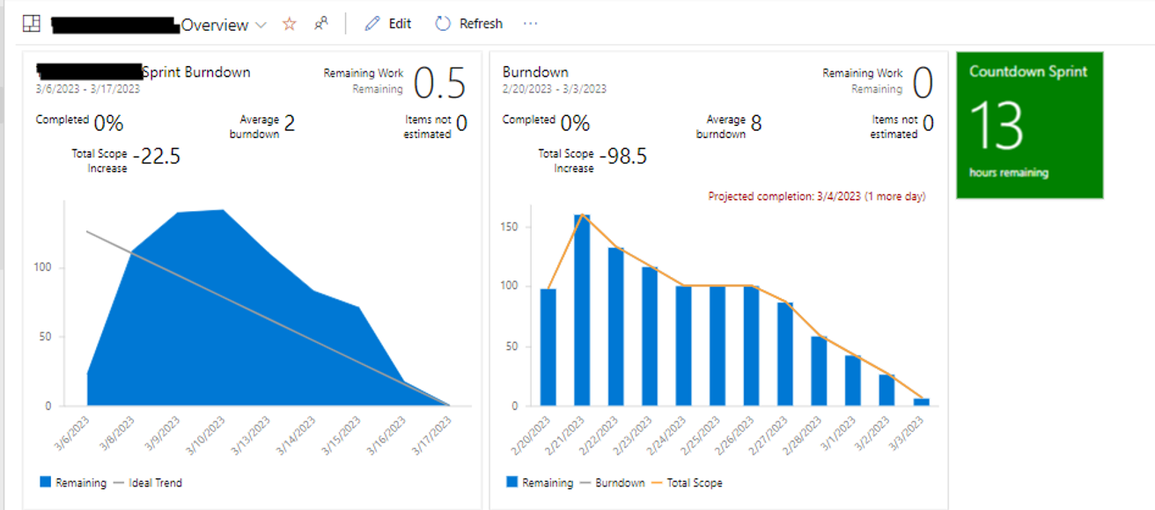

* **Estimation -** In sprint planning meeting, PM will give or assigns task/work to every developer & tester. PM has assigned task TCD & TCE to Tester (me). PM will ask estimation. Estimation is nothing but time to complete the work/ task.
* **Estimation will give by consider points,**

1. How much knowledge you have about the US.
2. How much efforts will be required for testing.
3. How much complex the US. (Ex. Testing = Order PDF check – 1 item, 2 item, 3 item, 4 item …… 20 items.)

* In real project, PM already will give rough estimation to task/ work. PM confirmation these time from tester.

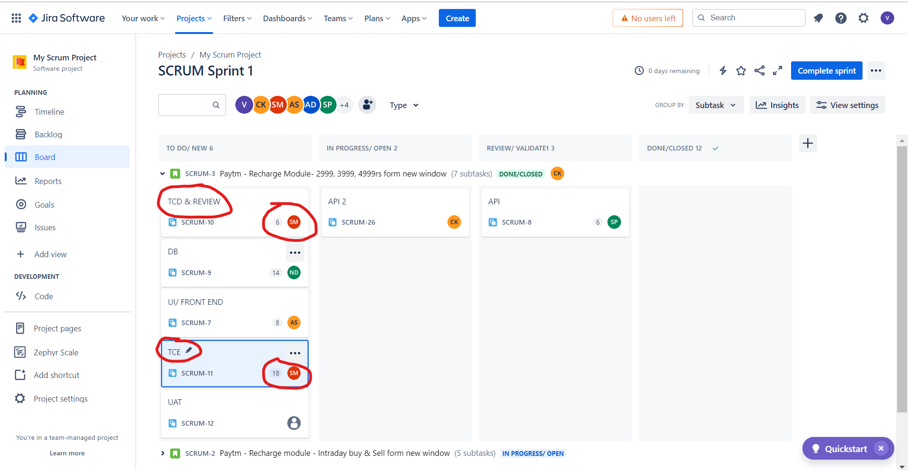

* **Story point –** The time which is given to US in term of points that ids called as story points. Accordingly, to Story points, company will charge to the client.
* **Ex**. 1US (Story point = 5 points = 40hr/8hr = 5 days = Development = Front end task (8hr- estimation) + API task (6hr) + DB test (8hr) + Testing = TCD (6hr- estimation) + TCE (12hr- estimation).



* **Scrum of scrum meeting- Main manager or scrum of scrum master** will conduct one meeting with all PM, these meeting are called scrum of scrum meeting.
* **Ex**. Project = [One97 Communications](https://www.google.com/search?sca_esv=9fc63cc73e9e59b8&rlz=1C1ONGR_enIN1071IN1071&q=One97+Communications&si=AKbGX_qWtsfHufXsq_1jeDkJp50FstNngDxsch3EVTUjn7imcH-qO5s2Te55-BjPkSZkYrlswlR5uOpkfbENZPBM6hRBnaJgGirhVsLd1L8JJrAPCOrA-Tryh_Q3rPhKcOR46bCWB1-DN_Cex6xu9cuwyJO8wJhKuVK16hdbv_umuXH2i25H14cAZaSLQkp5D7eQIrIzwm4UlJoJKl4WCQoWOYI51Q9kRA%3D%3D&sa=X&ved=2ahUKEwisvLWU9d-EAxXTm68BHTFKDZwQmxMoAXoECF8QAw)–

**1 module – Reacher module**

**2 Module – Movies module** [**www.paytm.com**](http://www.paytm.com) **– project Team = 16 - PM1**

**3 Module – Fasttag module**

**4 Module – Stock market -**

**5 module – IPO www.paytmmoney.com – project Team = 25 – PM2**

**6 Module – MF buy/sell**

**7 module -**

**8 module –** [**https://paytmmall.com**](https://paytmmall.com) **- project Team = 30 – PM3**

**9 module -**

* PM1, PM2 & PM3 will be report to main project manager/ Scrum of scrum master.

## Agile Principles/ Agile Manifesto-

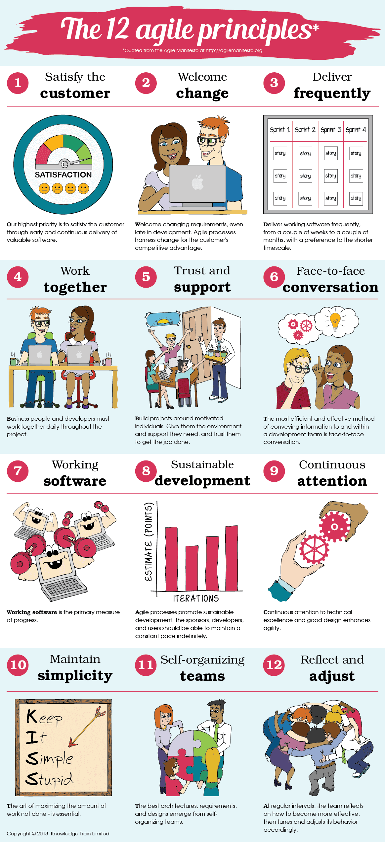

1. **Customer satisfy** – by doing deployment with 2 weeks.
2. **Well come changes** – Any CR comes at any points then we will accept these CR in current sprint.
3. **Delivery frequency –** Sprint wise delivery with 2 weeks.
4. **Work Together –** US work will be taken by = Development + Testing + Deployment done by developer.
5. **Trust & Support –** Trust & support will get within a team.
6. **Face to Face conversion –** InDaily stand-up meeting
7. **Working software –** In demo we are giving demo/ review to working application and same will be deployed to client.
8. **Sustainable development –** In every sprint, we are delivery 6US, In next sprint 7US, in next sprint 8US, in next sprint 9US, etc. For sustainable development we will check velocity chart.
9. **Continues attention –** iterative process / continues process for development and testing and development.
10. **Maintain simplicity –** US – work decide – Frond end, API, DB & Testing.
11. **Self-organized –** In daily stand-up meeting. (If developer completed the build, then tester immediately start the TCE)
12. **Reflect & Adjustment –** Functionality implement developer Frond end work + API work + DB work will adjust work accordingly.

**Scrum board-** 

**Kanban board-** 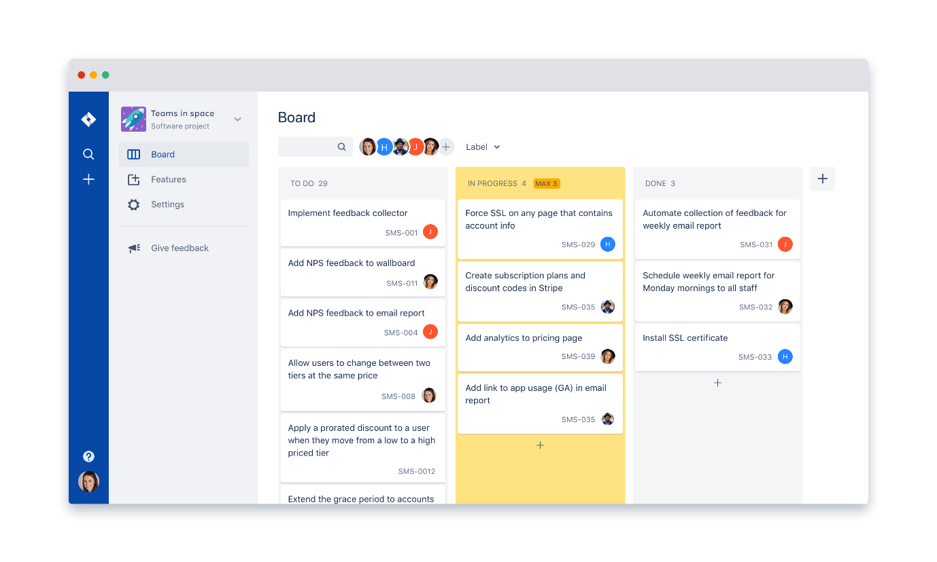

|  |  |
| --- | --- |
| **Scrum Board** | **Kanban Board** |
| Project team will work in scrum board. | Support team will work in Kanban board. |
| Project team always work in US | Support team always work in Bug, end user Quires, Ticket, Enhancement, CR, etc |
| After completion of all US in a current sprint, we will delivery to client | After completion of all Bug/ end user Quires/ Ticket/ Enhancement/ CR, etc in a current sprint, we will delivery to client |
| Delivery with 2 weeks. | Delivery with 2 weeks which has completed Bug/ end user Quires/ Ticket/ Enhancement/ CR, etc |

## Agile Advantages & Dis-advances-

**Advantages -**

1. In agile we will delivery US with 2 weeks.
2. If any CR comes then we will accept at any point accepted.
3. Daily wise meeting / Scrum meeting – to discuss daily work progress
4. Automation is possible over in sprint.

**Dis-Advantages -**

1. If any frequent changes occurred in the US/ requirement becz very difficult to complete work with 2 weeks.
2. If we have dependency one module into another module.

PVR, INOX, etc – Module

Bank – SBI, ICIC, Axis, etc

Paytm –

Movies module,

UPI module

**Interview question -**

1. What is your team size OR tell me how many people are present in your last project.
2. What is SDLC and what contain in SRS documents?
3. What is V-module & What are disadvantages?
4. What is Verification & Validation?
5. What is WBT & BBT?
6. What is Agile, Scrum, Sprint?
7. What are agile ceremonies/ meeting?

* **Answer** – 5 meeting names

1. What you are doing in daily stand-up meeting?

# IT Related knowledge –

* Resign / paper dala – **Notice period – 1 month/ 2 month / month**
* Project XYZ– Sumit Tester work– 2 exp/ 3 exp – Resign current project.

1. New tester opening – job searcher - Project XYZ allocation.
2. Company existing tester/ Bench period (no project allocation) – Project XYZ allocation.

* KT for Project XYZ – Sumit (Resign current project) will give KT to new tester (New hiring/ Company existing tester).
* Initially, for new tester (Me) small work will be allocated and if we have doubt or small problem then we will ask to person who has resigned or to the buddy (who give the guide to you).
* If you are working new in project then in 1 month you have allocated only on 1 US or 2 US on a sprint becz you are new in project and project knowledge.